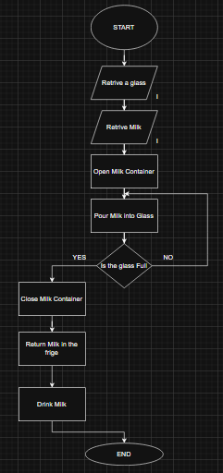
Start the process, find and pick up a clean glass from the table, subsequently open the fridge and take out the milk container, remouve the cap from the milk container and pour milk into the glass. If the glass hasn’t reached the desired level return to pour more milk, otherwise close the milk container and place the milk container back into the fridge. In the end consume the milk from the glass.

